From Plant Microbiomes To New Explotable Bioproducts for the Agri-Industry

The team “Biotechnology of Rhizospheric Bacteria” from the Instituto Valenciano de Investigaciones Agrarias (IVIA, Valencia, Spain) leaded by PhD. Ramón Penyalver is focus on the selection of potential microbes, genes or proteins of biotechnological interest derived from the analysis of plant microbiomes by using metagenomic approaches. Our main goals are to obtain, analyze, exploit and manipulate the microbiota of important crops and their corresponding genomes (microbiomes) in order to develop new biotechnological products for the Agri-industry.

Our specific tasks could be:

Task 1:

- Industrial need (Biotechnological challenge): Increase tolerance to water stress on citrus
- Workpackages (Scientific approach): Comparison and prediction of functional attributes of citrus microbiomes (metagenomic and metatranscriptomic) under different drought conditions
- Expected impact (Delivarables): Identification of potential microbes, genes or proteins increasing tolerance to water stress.
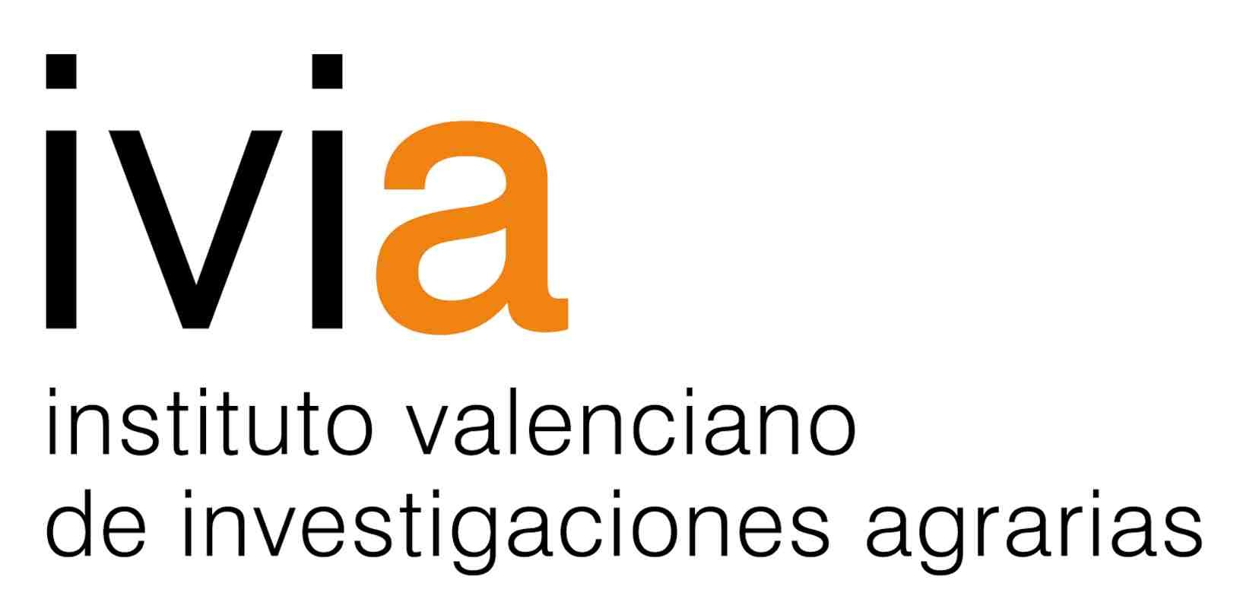
- Future innovation projects: Developing new bioproducts for saving water on citrus crops

Task 2:

- Industrial need (Biotechnological challenge): Increase tolerance to cold temperatures on sweet pepper
- Workpackages (Scientific approach): Comparison and prediction of functional attributes of pepper microbiomes (metagenomic and metatranscriptomic) under different temperature conditions
- Expected impact (Delivarables): Identification of potential microbes, genes or proteins reducing culture temperatures (energy inputs).
- Future innovation projects: Developing new bioproducts for saving greenhouse energy inputs on pepper crops (reducing cost).

Task 3:

- Industrial need (Biotechnological challenge): Increase tolerance to salt stress on sweet pepper
- Workpackages (Scientific approach): Comparison and prediction of functional attributes of pepper microbiomes (metagenomic and metatranscriptomic) under different salt conditions
- Expected impact (Delivarables): Identification of potential microbes, genes or proteins increasing tolerance to salt stress.
- Future innovation projects: Developing new bioproducts for improving productivity on sweet pepper crops

Task 4:

- Industrial need (Biotechnological challenge): Increase nutrient availability on tomato
- Workpackages (Scientific approach): Comparison and prediction of functional attributes of tomato microbiomes (metagenomic and metatranscriptomic) under nutrient limitations
- Expected impact (Delivarables): Identification of potential microbes, genes or proteins reducing nutrient inputs.
- Future innovation project subjects: Developing new bioproducts for saving nutrient inputs on tomato crops (reducing cost).

Task 5:

- Industrial need (Biotechnological challenge): Increase tolerance to salt stress on tomato
- Workpackages (Scientific approach): Comparison and prediction of functional attributes of tomato microbiomes (metagenomic and metatranscriptomic) under different salt conditions
- Expected impact (Delivarables): Identification of potential microbes, genes or proteins increasing tolerance to salt stress.
- Future innovation projects: Developing new bioproducts for improving productivity on tomato crops

Task 6:

- Industrial need (Biotechnological challenge): Control of adventitious plants (weeds) on lettuce
- Workpackages (Scientific approach): Comparison and prediction of functional attributes of lettuce microbiomes (metagenomic and metatranscriptomic) in presence or absence of adventitious plants
- Expected impact (Delivarables): Identification of potential microbes, genes or proteins controlling adventitious (weeds) plants.
- Future innovation projects: Developing new biopesticides for weed control on lettuce crops

Ramón Penyalver
rpenal@ivia.es

